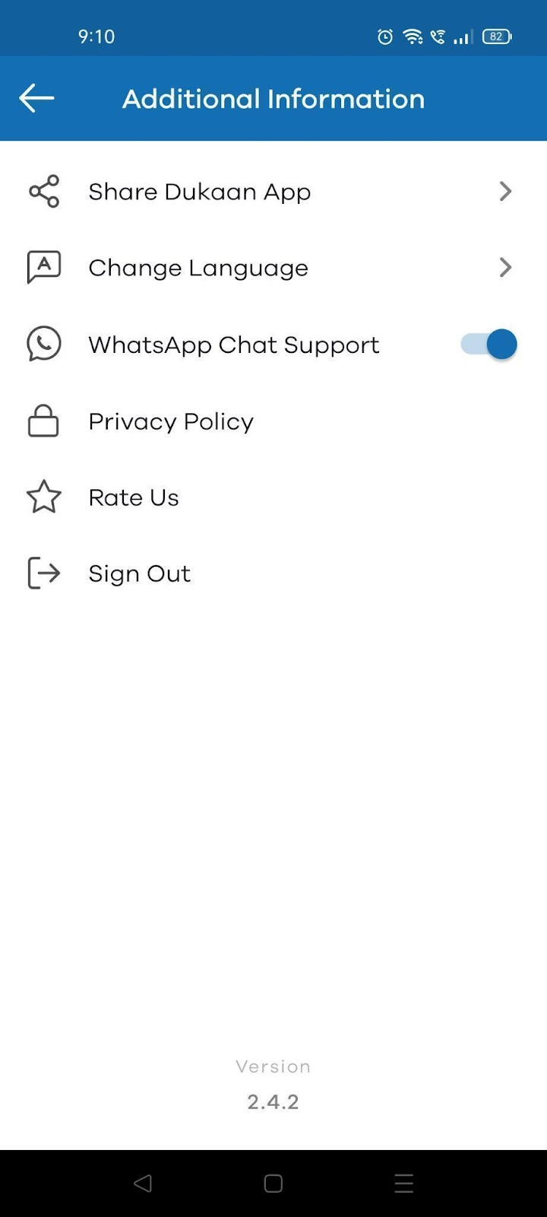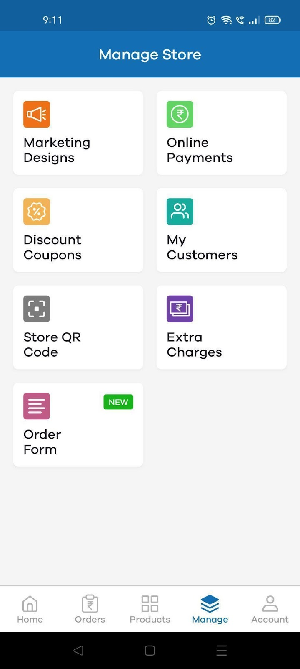

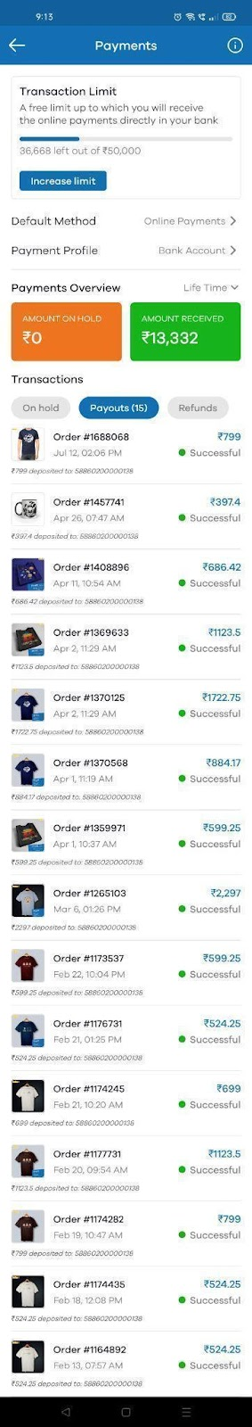

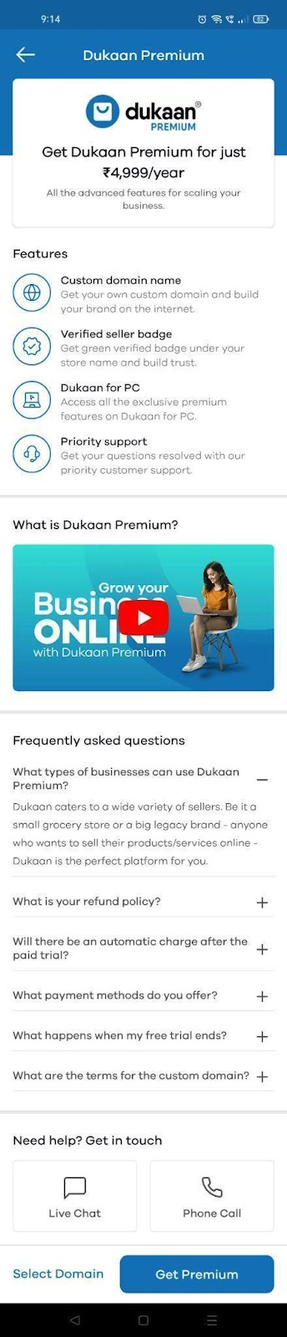

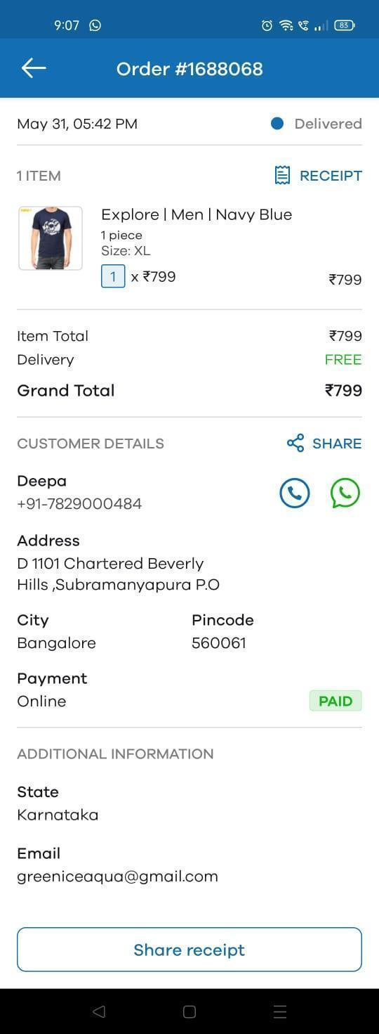

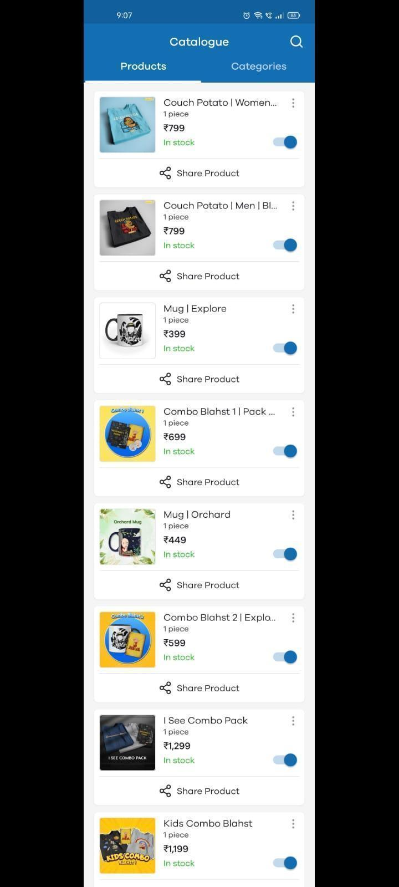

**Design all the UI screens given in the following document.**

* Create a camera application which performs the following functionalities.
* Should contain a button to access the phone’s camera
* Should be able to capture an image
* Captured image should be stored in a specific separate folder and it should be displayed in a custom gallery view.
* Prepare for your full domain review in which you have to revise all the previous weekly tasks including data structure workouts.